THE STANDARDIZATION GAP
Why Inconsistency Is the Biggest Problem in Talent Acquisition Today
Based on qualitative research with TA and HR leaders across industries

Executive Summary
Most talent acquisition teams are not falling short for lack of effort. They have the people, the tools, and, in many cases, the structured resources. What they are missing is consistency. Across our conversations with HR and TA leaders at organizations ranging from two-person HR teams to enterprise functions managing thousands of annual hires, one pattern emerged more clearly than any other: the tools exist, but adoption is uneven. The frameworks exist, but enforcement is rare. The process works when someone follows it and falls short when they do not.
This white paper synthesizes those findings into a single, evidence-backed argument: standardization is the highest-leverage improvement available to talent acquisition today. Not better AI. Not bigger teams. Not tools in isolation. Consistent, embedded process, applied at every stage from kick-off to final decision, is what separates teams that hire well from those that merely hire.

Thank you again for your invaluable time and insights.  We couldn’t have done it without you, so thank you for sharing a bit about your experience with us! You’re an essential part of this journey!  Interested in what we’re building? Join the waitlist at alynd.ca | For more, please visit:  alynd.ca

What We Heard
The interviews surfaced a wide range of operational challenges, but they clustered around a consistent core. The specific tools and team sizes varied enormously. One organization was managing nearly three thousand hires a year across multiple provinces. Another was a two-person HR team supporting a hundred and fifty employees. Yet the friction points were nearly identical. When we analyzed the full set of responses, interconnected problems kept surfacing regardless of company size, sector, or geography.

1. Inconsistent kick-off is where everything starts to break
The kick-off is the initial conversation between recruiter and hiring manager about a new role. It is the foundation of every search. When it is unclear, rushed, or undocumented, the problems compound at every subsequent stage. Teams described kickoff calls that happened over email instead of live discussion, notes stored in inboxes instead of systems, and role requirements that shifted midway through a search because alignment was never truly reached upfront. Without a structured kick-off, there is no shared definition of success. The recruiter and hiring manager are often solving for different versions of the same role, and neither realizes it until the process is already weeks in.

From the field
"Getting fifteen minutes on a hiring manager's calendar to define the role is somehow harder than getting three hours of their time to interview the wrong candidates."

2. Structured tools exist but go unused
Interview kits, scorecards, and evaluation guides are more common than the headlines might suggest. Many of the teams we spoke with had already built them. The problem is not that the tools do not exist. The problem is that adoption depends entirely on whether an individual recruiter or hiring manager chooses to use them on a given day. In multiple organizations, scorecards were described as technically available but functionally optional. Experienced recruiters bypassed structured guides in favor of their own methods. New managers had no idea the tools existed at all. The result is a process that looks standardized on paper but operates inconsistently in practice.

From the field
"Scorecards exist but are ignored. They're inconvenient. And if the system doesn't require it, most managers won't do it."

FIGURE 3 — PROCESS MATURITY SNAPSHOT
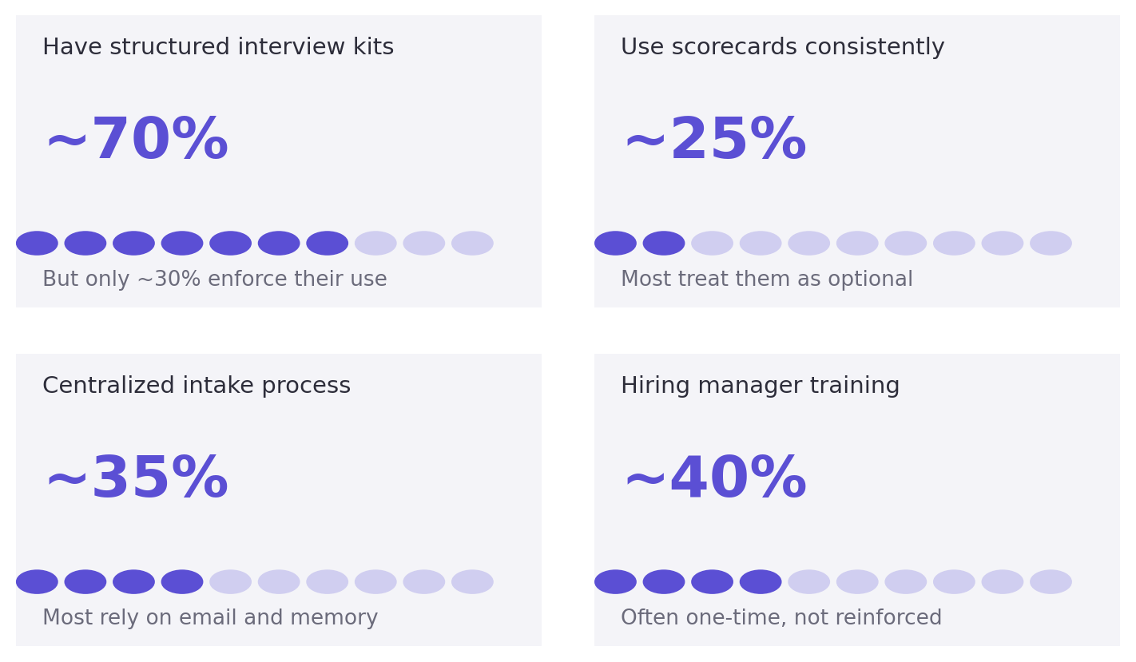
Prevalence of structured hiring practices, and the gap between having them and consistently enforcing them

The Root Cause
Every problem described above shares a common structure. There is a defined way things should be done. That definition lives somewhere, whether in a documented SOP, a kit, a template, or simply an unwritten expectation that has never been formalized. But the process does not enforce it. It relies on individuals to remember, choose, and follow through. Under normal workload conditions, in the middle of managing fifteen or twenty open roles simultaneously, that is not a reliable mechanism. It is not a people problem. It is a design problem.
Standardization is not about rigidity or removing human judgment from hiring. It is about making the right way the default way, so that good process happens automatically rather than depending on discretion. The teams that had the most consistent hiring outcomes in our interviews were not the ones with the most sophisticated technology or the largest recruiting functions. They were the ones where structure was embedded into the work itself. Kick-off structure that prompted the right questions. Scorecards that were required before a decision could progress. Hiring manager workflows built into the system rather than explained once in a training session and then forgotten.

Key insight
The gap between having a process and consistently running one is where hiring quality, speed, and fairness are lost. Closing that gap does not require more tools. It requires structure that travels with the work, at every stage, for every role.

What Good Looks Like
A handful of organizations in our interview set had moved meaningfully closer to consistent execution. The common thread was not budget, headcount, or any particular platform. It was intentionality about where structure was embedded and a willingness to make the right behavior the easy behavior. Across those organizations, a clear set of practices distinguished them from the rest.
- Kick-off is formalized and stored in a shared system, not conducted over email and forgotten
- Job descriptions are derived directly from structured role information, not written from memory or recycled from previous postings
- Interview questions are tied to defined competencies and shared with interviewers before the conversation begins
- Scorecards are required at the point of decision, not optional after the fact, and they reflect the criteria agreed at kick-off
- Hiring manager guidance is embedded into the workflow itself, not delivered once in a training session months before it is needed
- AI is used as a structured assistant to generate, draft, and flag, not as a replacement for human judgment on final decisions

The encouraging finding is that none of this requires a transformation. It does not require a new ATS or a year-long implementation. It requires a layer of structure applied consistently at the moments that matter most: when a role opens, when an interview is designed, and when a hire decision is made. Organizations that get this right do not just hire faster. They hire better, with less rework, less legal exposure, and a candidate experience that reflects the employer they are trying to be.

We are in active research with TA professionals.  If you recruit in-house and would like to contribute, we would value 20 minutes of your time. Every conversation shapes what Alynd becomes.  Interested in what we’re building? Join the waitlist at alynd.ca | Book a conversation  alynd.ca

alynd | Bringing structure to talent acquisition
alynd.ca

